IOT Sensor Data Analysis Pipeline
Vehicle Health Monitoring & Predictive Maintainance
Problem Statement - Unexpected vehicle breakdowns cost businesses money and lead to downtime.

Solution – Build a glue pipeline that processes RPM , engine load , coolant temp (cTemp) , and DTC codes in real-time to:
- Detect early signs of engine trouble.
- Trigger alerts for overheating , frequent high RPMs , low battery, or high eLoad.

Pipeline Outcome:
- Alerting systems on anomalies.
- Maintenance recommendation.
- Aggregated health reports in Clickhouse for dashboards.

Made By:
I Aditya Kumar

1. Architecture Diagram:
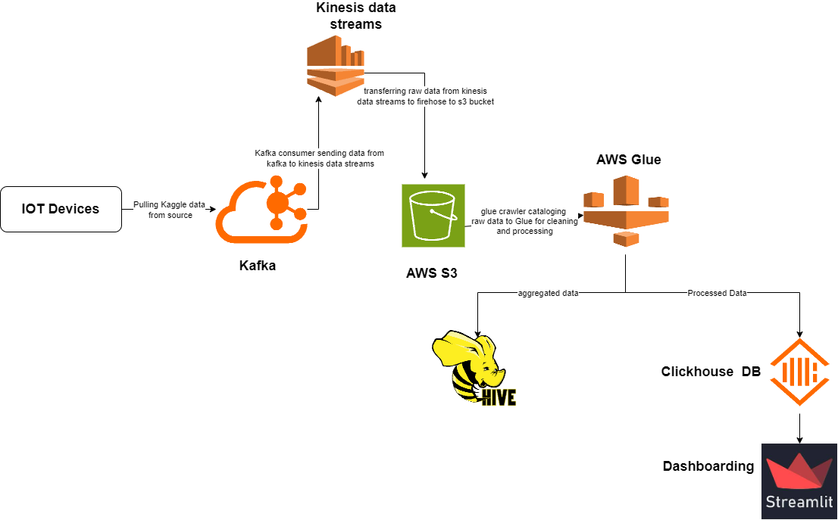

2. Prerequisites:
- Kafka Instance
  - Deployed on EC2 intance for real – time data ingestion.
  - Recieves raw sensor data from vehicles in JSON format.
- AWS Services used
  - AWS Kinesis – for data streaming.
  - Kinesis Firehose – for delivering raw data to S3.
  - AWS S3 – Used to store raw, processed, and aggregated data.
  - AWS Lambda – Trigger on data arrival in S3 and starts the Glue Crawler and ETL Jobs.
  - AWS Glue – Performs ETL on raw data and writes clean and aggregated outputs to S3.
  - Clickhouse DB – used for fast analytical querying and reporting (OLAP).
  - Hive – used for schema validation and querying during data QA stages.
  - Athena (optional) – for ad hoc queries on S3 datasets.

3. Data Source:
This dataset captures real-time telematics data collected from multiple vehicles during operational trips. Each record corresponds to a single data point captured at a specific timestamp by a vehicle’s onboard device. The dataset includes parameters related to vehicle performance, engine diagnostics, driver behavior, and GPS location.

4. Data Flow Description:
- Raw Sensor Data
Format: JSON
Example Fields: tripID, deviceID, timestamp, accData, gps_speed, battery, etc.
- ETL 1 – Cleaning
Location: s3://your-bucket/vehicle_health/
Converts JSON to Parquet, casts types, removes corrupted/missing values.
- ETL 2 – Aggregation
Location: s3://your-bucket/vehicle_health_agg/
Aggregated per deviceID per day.
Columns: deviceID, date, avg_rpm, max_rpm, avg_engine_load, max_coolant_temp, records.

5. Data Ingestion
- Convert CSV to JSON format
  - Load the telemetry dataset file in .csv format.
  - Create a Python script to convert the csv file into json format.
  - Run the script to generate the output.json file.

Python Script:
import csv
import json

input_csv = r"path\to\csvfile\vehicle.csv"
output_json = r"path\of\json-file\output.json"

with open(input_csv, mode="r", encoding="utf-8") as csv_file, \
open(output_json, mode="w", encoding="utf-8") as json_file:

reader = csv.DictReader(csv_file)

for row in reader:
json_line = json.dumps(row)
json_file.write(json_line + "\n")

print("Success")

- Create Kafka Topic
  - SSH into EC2 instance where Apache Kafka is installed.
  - Run the following command to create the topic.

Command:
bin/kafka-topics.sh \
--create \
--topic iot_pipeline \
--bootstrap-server localhost:9092 \
--partitions 1 \
--replication-factor 1

- Run kafka Producer
  - Use the python `kafka-python` library to public the JSON records to the kafka topic.
  - Create the following script.
Kafka_producer.py
from kafka import KafkaProducer
from kafka.errors import KafkaError
import json
import time
import logging

logging.basicConfig(level=logging.INFO, format="%(asctime)s %(levelname)s: %(message)s")

producer = KafkaProducer(
bootstrap_servers='localhost:9092',
acks='all',
retries=3,
value_serializer=lambda v: json.dumps(v).encode('utf-8')
)

topic_name = "sensor-data"

def on_success(metadata):
logging.info(f"Sent to {metadata.topic} partition={metadata.partition} offset={metadata.offset}")

def on_error(excp):
logging.error(f" Failed to send: {excp}")

with open("output.json", "r") as file:
for line in file:
try:
data = json.loads(line)
future = producer.send(topic_name, value=data)
future.add_callback(on_success)
future.add_errback(on_error)
time.sleep(0.1)
except json.JSONDecodeError as e:
logging.error(f"Invalid JSON line: {e}")
except Exception as e:
logging.error(f"Unexpected error: {e}")

producer.flush()
producer.close()

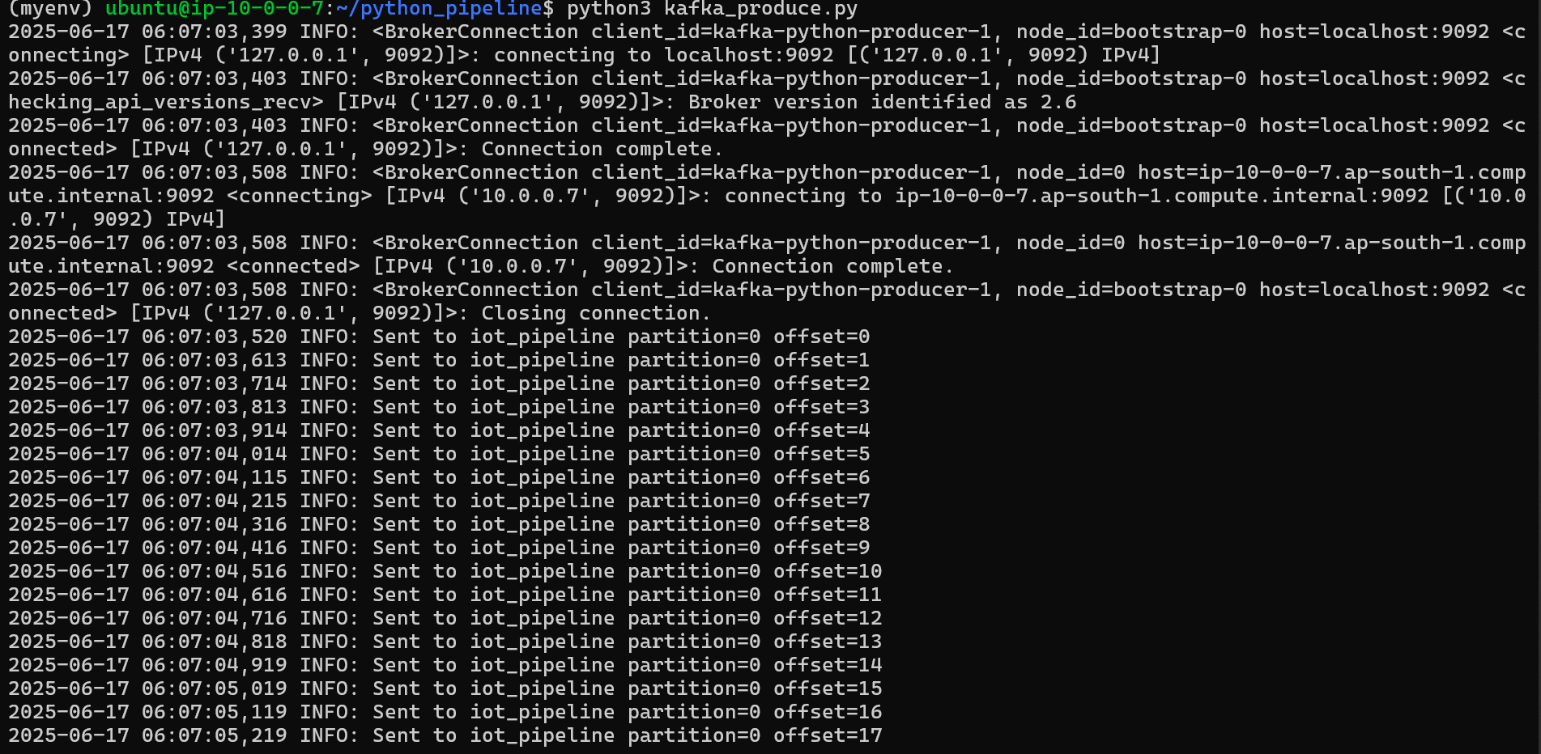
- Create and configure Kafka Consumer -> Kinesis Forwarder
  - Install `boto3` and `kafka-python` in EC2 instance.
  - Create a script to consume kafka records and push them into Kinesis.

Kafka_consumer.py
import json
import os
import time
import boto3
import logging
from kafka import KafkaConsumer
from botocore.exceptions import ClientError

BOOTSTRAP = os.getenv("BOOTSTRAP", "localhost:9092")
TOPIC = os.getenv("TOPIC", "iot_pipeline")
STREAM = os.getenv("STREAM", "my-stream")
REGION = os.getenv("REGION", "ap-south-1")
BATCH = int(os.getenv("BATCH", "50"))
FLUSH_INTERVAL = 10

logging.basicConfig(
level=logging.INFO,
format="%(asctime)s %(levelname)s %(message)s"
)

try:
sts = boto3.client("sts")
identity = sts.get_caller_identity()
logging.info("Running as AWS identity: %s", identity["Arn"])
except ClientError as e:
logging.error("Failed to get AWS identity: %s", e)

consumer = KafkaConsumer(
TOPIC,
bootstrap_servers=[BOOTSTRAP],
auto_offset_reset='earliest',
enable_auto_commit=True,
group_id="iot_to_kinesis_debug",
value_deserializer=lambda b: b.decode("utf-8"),
)

kinesis = boto3.client("kinesis", region_name=REGION)

batch = []
last_flush = time.time()

def flush():
global batch
if not batch:
return

try:
resp = kinesis.put_records(StreamName=STREAM, Records=batch)
failed = resp["FailedRecordCount"]
logging.info("Sent %d records (failed=%d)", len(batch), failed)

if failed > 0:
logging.warning("WARNING: %d records failed to put into Kinesis", failed)
logging.debug("Full response: %s", json.dumps(resp, indent=2))

except ClientError as e:
logging.error("AWS error: %s", e)

batch = []

logging.info("Started forwarder Kafka → Kinesis (%s → %s)", TOPIC, STREAM)

try:
for msg in consumer:
logging.info("Consumed message: %s", msg.value)

batch.append({
"Data": msg.value.encode("utf-8"),
"PartitionKey": "pk"
})

if len(batch) >= BATCH or (time.time() - last_flush >= FLUSH_INTERVAL):
flush()
last_flush = time.time()

except KeyboardInterrupt:
logging.info("Stopping…")
flush()

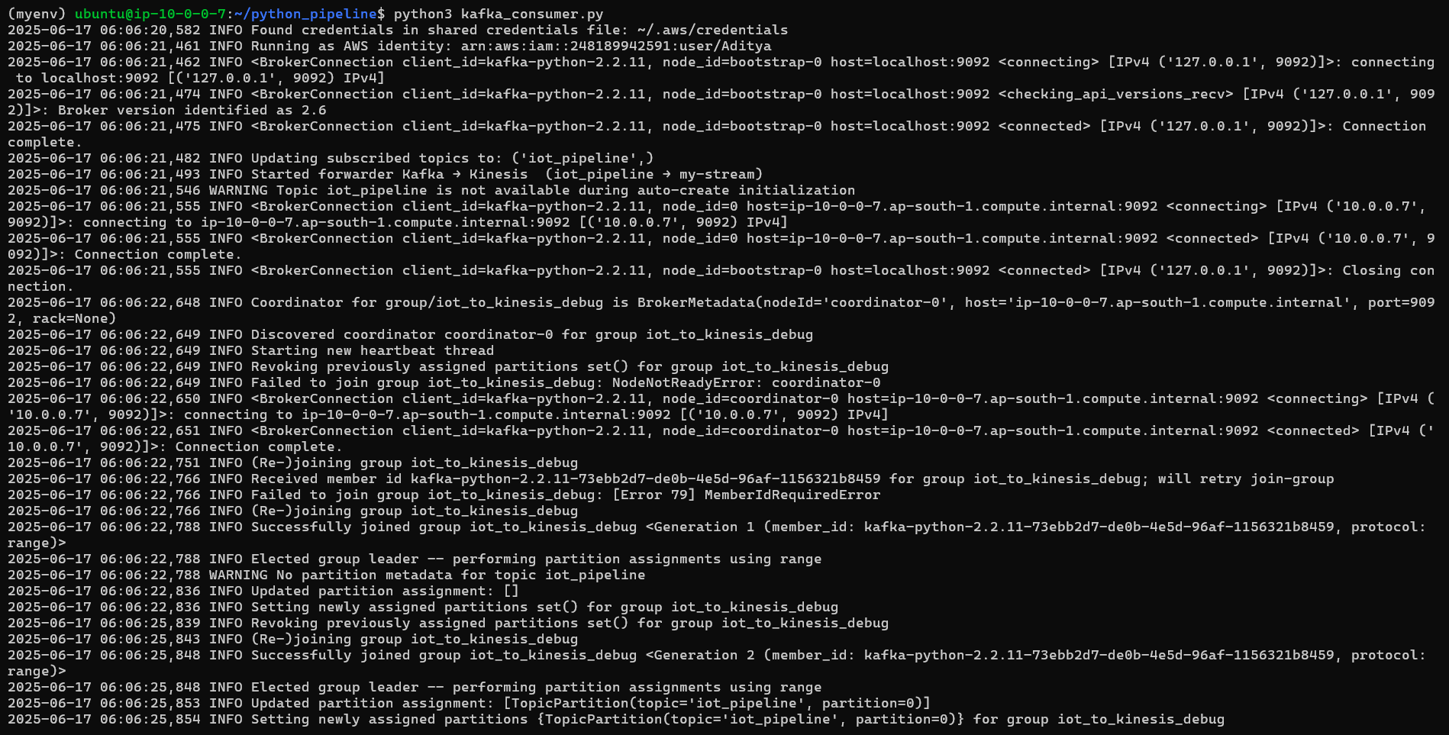

- Data is sent to kinesis data streams from where Kinesis Firehose pushes the data into S3 bucket (aditya-bucket-raw).
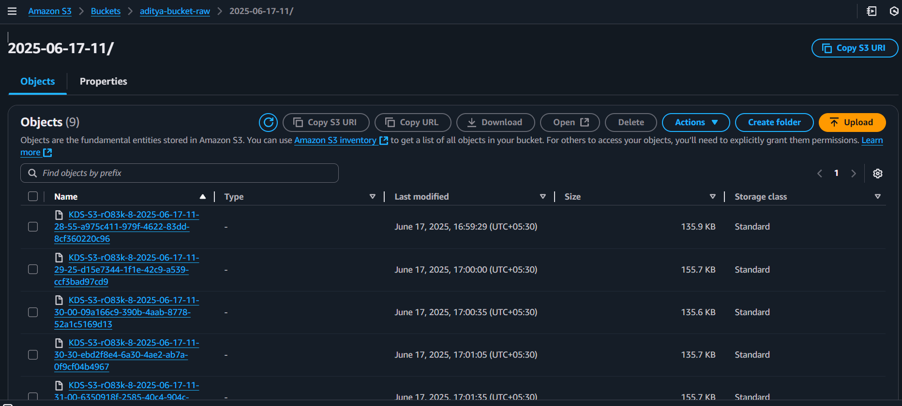

6. ETL Processing, Cataloging and Data Cleaning
- Trigger AWS Lambda on S3 PUT event
  - A lambda function is configured to get triggered on every new object upload to `aditya-bucket-raw/`.
- The Lambda Function performs the following tasks:
  - Starts a Glue Crawler that scans the S3 location.
  - The crawler updates or creates a table in the Glue Data Catalog.

Lambda_function.py
import boto3
import urllib.parse

glue = boto3.client('glue')

def lambda_handler(event, context):
bucket = event['Records'][0]['s3']['bucket']['name']
key = urllib.parse.unquote_plus(event['Records'][0]['s3']['object']['key'])

print(f"New file in S3: s3://{bucket}/{key}")

response = glue.start_job_run(
JobName='Vehicle-stream',
Arguments={
'--source_s3_path': f's3://{bucket}/{key}'
}
)

print(f"Glue job started: JobRunId = {response['JobRunId']}")
return {
'statusCode': 200,
'body': f"Triggered Glue job for s3://{bucket}/{key}"
}

- Glue Crawler: Create Table in Glue Database
  - The Crawler scan the raw S3 data in JSON format and creates a table in:
    - Database: `testdb`
    - Table: `vehicle_health_raw`
- This table allows querying raw JSON using Athena or Glue.

- GLUE JOB 1: Clean and Process the RAW data
A Glue Job is triggered via Lambda function.
Input = s3://aditya-bucket-raw/
Output = s3://aditya-bucket-processed/

etl-job-1.py
RAW_DB = "testdb"
RAW_TABLE = "aditya_bucket_raw"
PROC_PATH = "s3://aditya-bucket-processed/vehicle_health/"

NUMERIC_COLS = [
"gps_speed", "battery", "cTemp", "dtc", "eLoad",
"iat", "imap", "kpl", "maf", "rpm", "speed", "tAdv", "tPos"
]

from pyspark.context import SparkContext
from pyspark.sql import functions as F
from awsglue.context import GlueContext

sc = SparkContext()
glueContext = GlueContext(sc)
spark = glueContext.spark_session
spark.conf.set("spark.sql.caseSensitive", "false")

df = (glueContext
.create_dynamic_frame_from_catalog(database=RAW_DB, table_name=RAW_TABLE)
.toDF())

print("RAW rows :", df.count())

for col in NUMERIC_COLS:
if col in df.columns:
df = df.withColumn(col, F.col(col).cast("double"))

if "timeStamp" in df.columns:
df = df.withColumn("timeStamp", F.to_timestamp("timeStamp"))

df = df.filter(F.col("tripID").isNotNull() & F.col("deviceID").isNotNull())

print("CLEAN rows:", df.count())

(df.write
.mode("overwrite")
.parquet(PROC_PATH))

print(f"Cleaned data written → {PROC_PATH}")

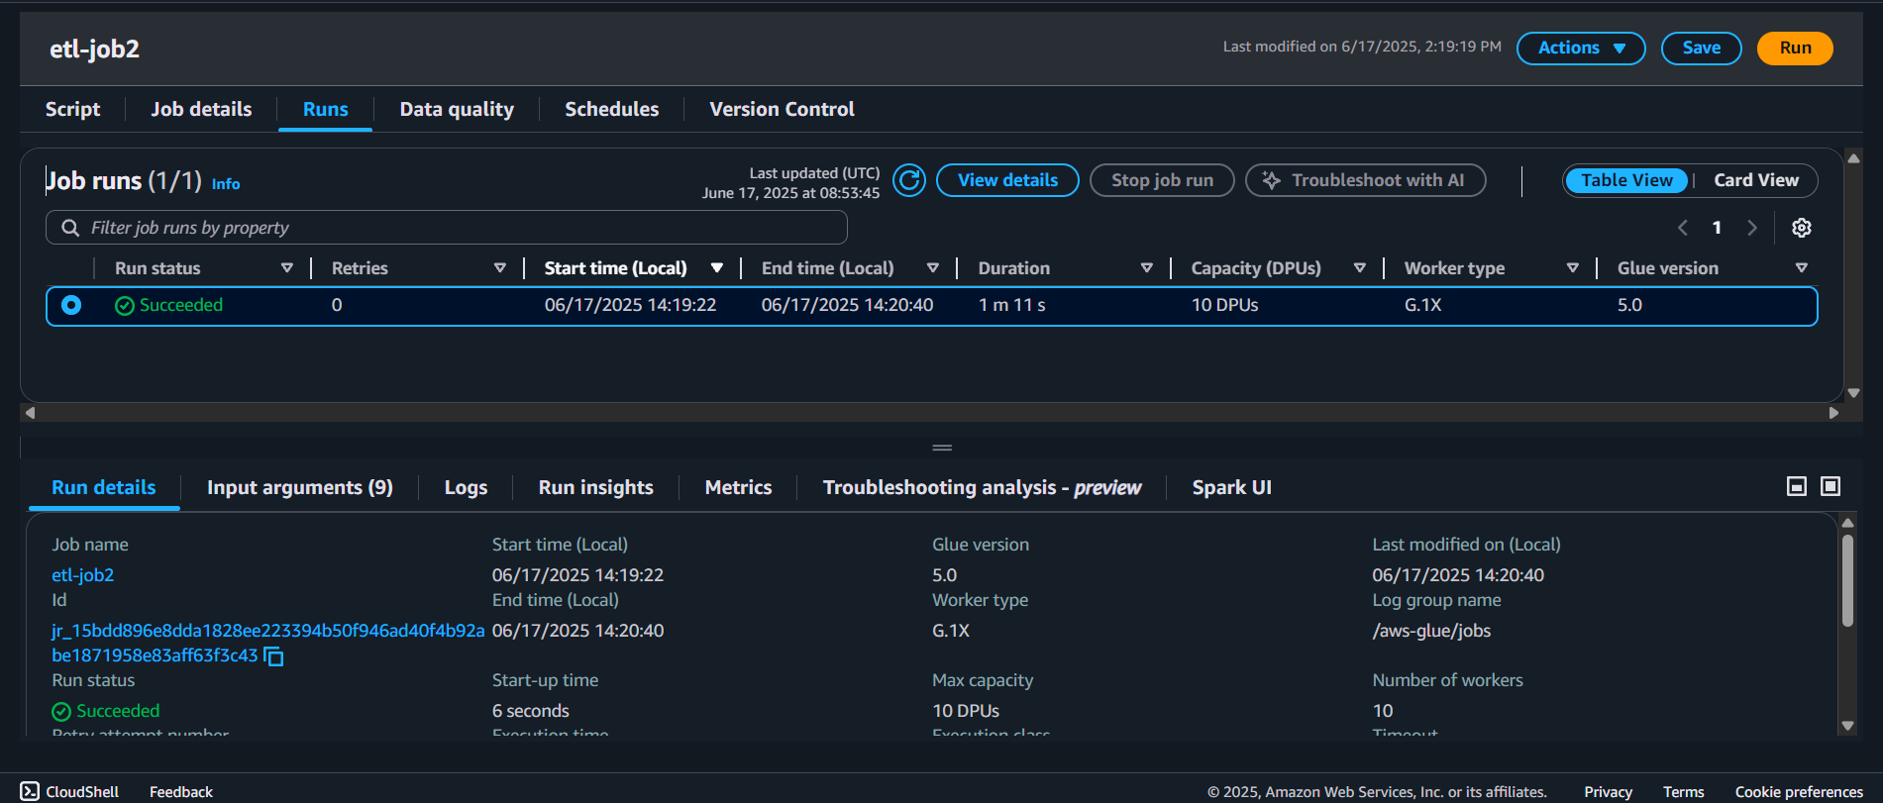

- GLUE JOB 2 – Aggregate Cleaned DATA
A second Glue Job runs to aggregate data per deviceID and date.
Input = s3://aditya-bucket-processed/
Output = s3://aditya-bucket-aggregated/

etl-job-2.py
CLEAN_PATH = "s3://aditya-bucket-processed/vehicle_health/"
AGG_PATH = "s3://aditya-bucket-aggregated/vehicle_health_agg/"

from pyspark.context import SparkContext
from pyspark.sql import functions as F
from awsglue.context import GlueContext

sc = SparkContext()
glueContext = GlueContext(sc)
spark = glueContext.spark_session

df = spark.read.parquet(CLEAN_PATH)
print("RAW rows :", df.count())

df = (df
.withColumn("rpm", F.col("rpm").cast("double"))
.withColumn("engine_load", F.col("eLoad").cast("double"))
.withColumn("coolant_temp", F.col("cTemp").cast("double"))
)

df_agg = (df
.withColumn("date", F.to_date("timeStamp"))
.groupBy("deviceID", "date")
.agg(
F.avg("rpm").alias("avg_rpm"),
F.max("rpm").alias("max_rpm"),
F.avg("engine_load").alias("avg_engine_load"),
F.max("coolant_temp").alias("max_coolant_temp"),
F.count("*").alias("records")
)
)

print("AGG rows :", df_agg.count())

(df_agg.write
.mode("overwrite")
.partitionBy("date", "deviceID")
.parquet(AGG_PATH))

print(f"Aggregated parquet written → {AGG_PATH}")

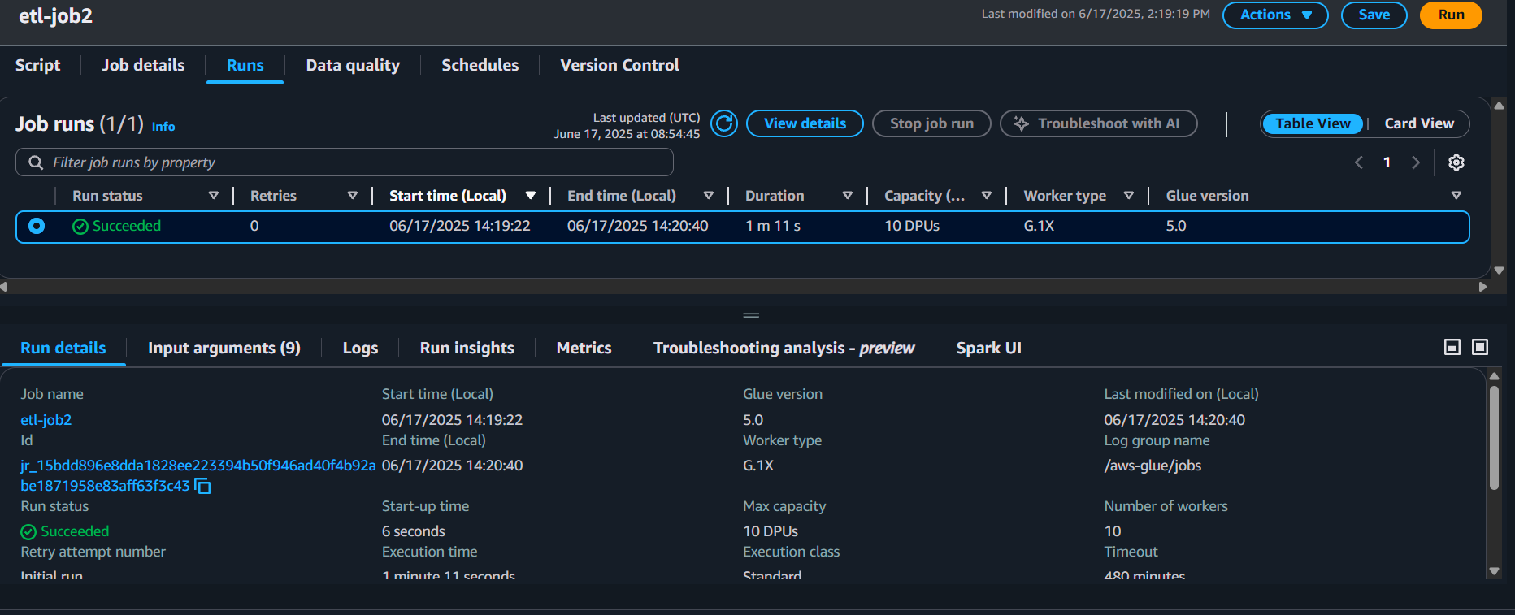

This is How the it will be present in S3.
Processed-data
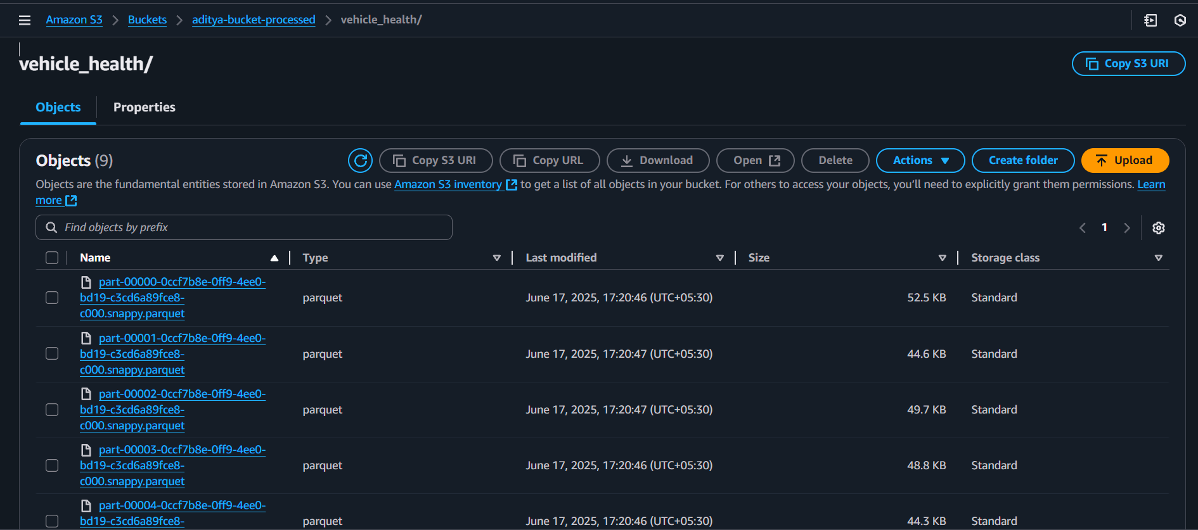

Aggregated-data
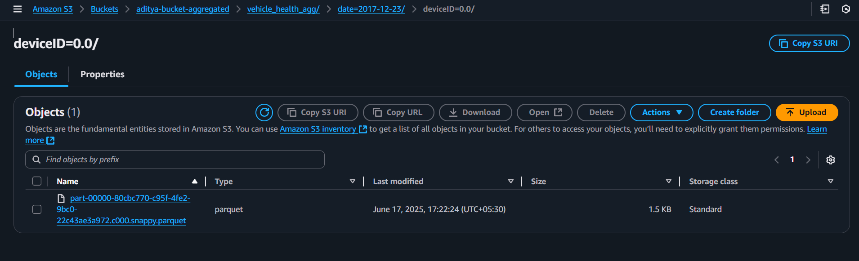

7. Hive Querying
- EMR is used for hosting Hive and access the processed data.
- Connect to EMP via SSH using below command.
ssh -i <keypair.pem> hadoop@<EMR-Master-Public-DNS>
- Start Hive CLI
hive

- Create Hive Database
CREATE DATABASE IF NOT EXISTS testdb;
USE testdb;

- Create Hive External Table on Processed Data
CREATE EXTERNAL TABLE vehicle_health_processed (
tripID STRING,
deviceID STRING,
`timeStamp` STRING,
accData STRING,
gps_speed DOUBLE,
battery DOUBLE,
cTemp DOUBLE,
dtc STRING,
eLoad DOUBLE,
iat DOUBLE,
imap DOUBLE,
kpl DOUBLE,
maf DOUBLE,
rpm DOUBLE,
speed DOUBLE,
tAdv DOUBLE,
tPos DOUBLE
)
STORED AS PARQUET
LOCATION 's3://aditya-bucket-processed/vehicle_health/';

- Query it using HiveQL
SELECT * FROM vehicle_health_processed LIMIT 10;

Here is how it looks like
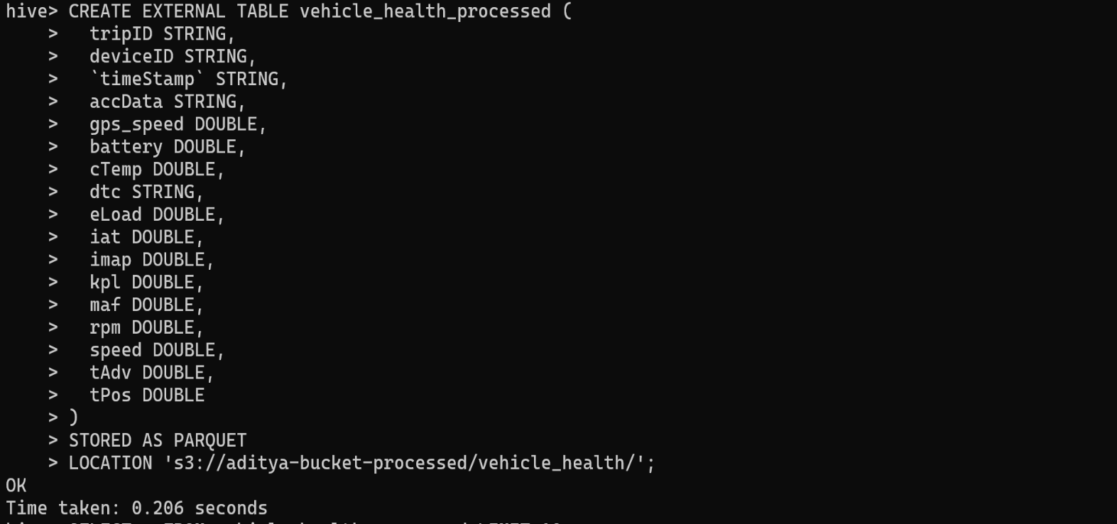
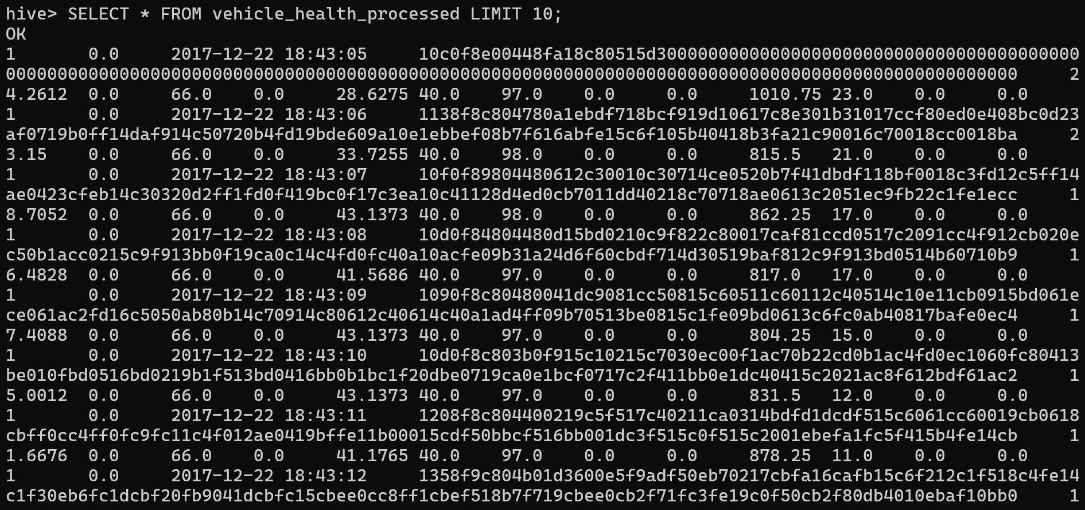
8. Clickhouse DB (OLAP)
After cleaning and aggregating the vehicle health data using AWS Glue jobs, both datasets (processed and aggregated) are loaded into ClickHouse Cloud, a high-performance OLAP (Online Analytical Processing) database optimized for fast analytical queries and dashboarding.

Queries for Clickhouse
drop table vehicle_health_aggregated;
drop table vehicle_health_processed;

CREATE TABLE IF NOT EXISTS vehicle_health_processed
(
tripID Int32,
deviceID String,
timeStamp DateTime,
accData String,
gps_speed Float64,
battery Float32,
cTemp Float32,
dtc Int32,
eLoad Float64,
iat Int32,
imap Int32,
kpl Float32,
maf Int32,
rpm Float64,
speed Float64,
tAdv Int32,
tPos Int32,
`date` Date MATERIALIZED toDate(timeStamp)
)
ENGINE = MergeTree
PARTITION BY toYYYYMM(`date`)
ORDER BY (deviceID, timeStamp);

CREATE TABLE IF NOT EXISTS vehicle_health_aggregated
(
`date` Date,
`deviceID` String,
`avg_rpm` Float64,
`max_rpm` Float64,
`avg_engine_load` Float64,
`max_coolant_temp` Float64,
`records` UInt32
)
ENGINE = MergeTree
PARTITION BY toYYYYMM(date)
ORDER BY (deviceID, date);

INSERT INTO vehicle_health_processed
SELECT *
FROM s3(
's3://aditya-bucket-processed/vehicle_health/part-00000-0ccf7b8e-0ff9-4ee0-bd19-c3cd6a89fce8-c000.snappy.parquet',
'Parquet'
);

INSERT INTO vehicle_health_aggregated
SELECT *
FROM s3(
's3://aditya-bucket-aggregated/vehicle_health_agg/date=2017-12-23/deviceID=0.0/part-00000-80cbc770-c95f-4fe2-9bc0-22c43ae3a972.c000.snappy.parquet',
'Parquet'

);

Here is how it looks in Clickhouse Cloud
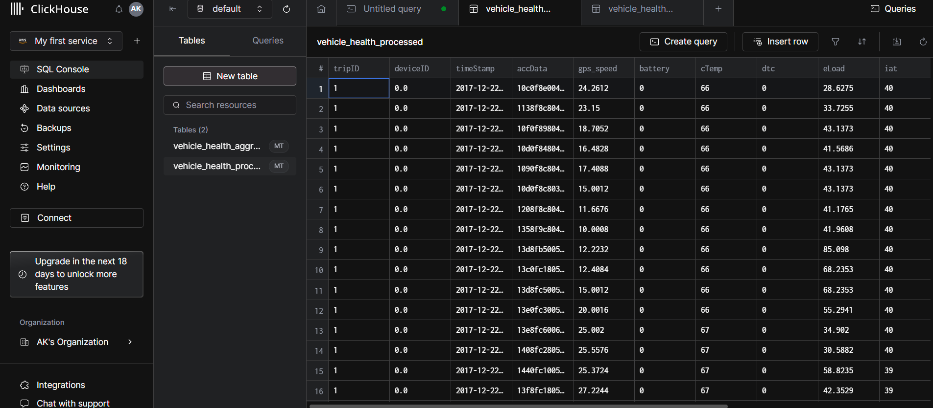

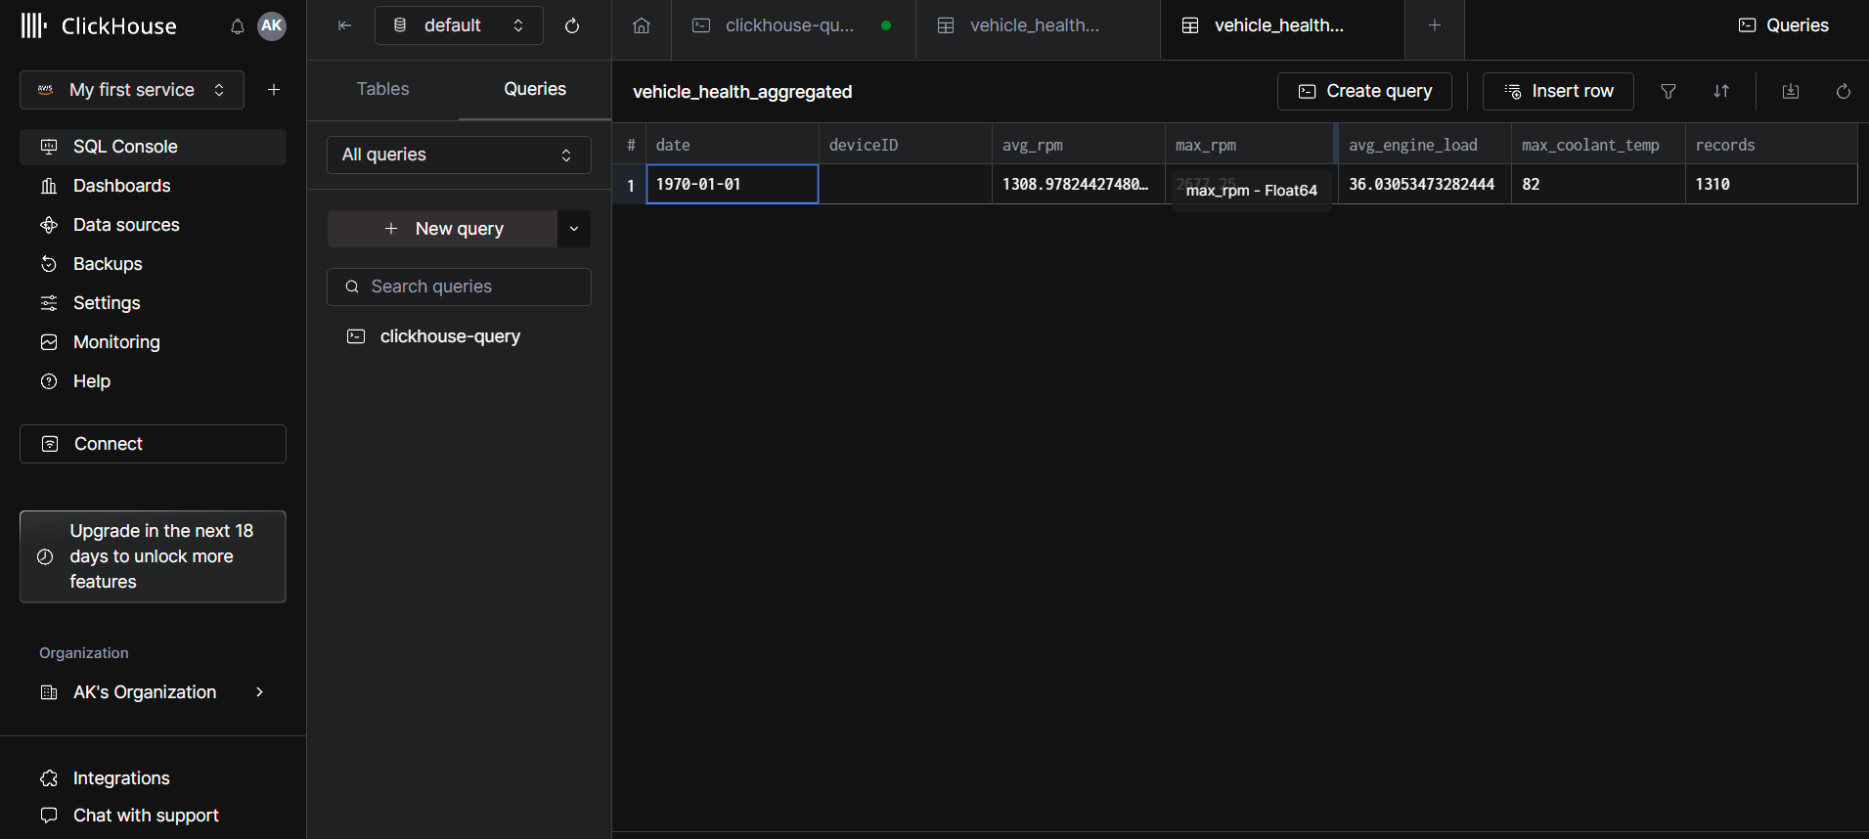

9. Dash-Boarding
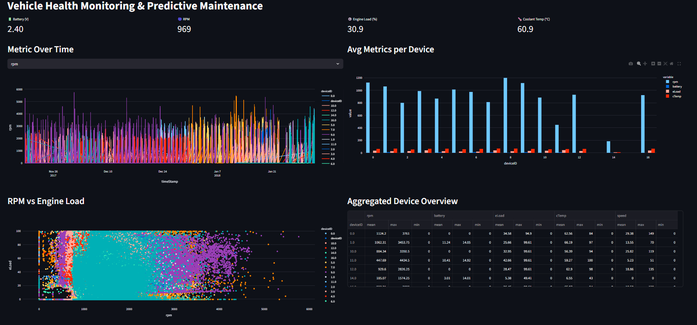

10. Reference
https://www.kaggle.com/datasets/yunlevin/levin-vehicle-telematics

